Banking System

Tasks 1: Database Design:

1. Create the database named "HMBank"

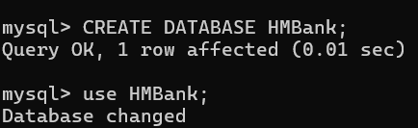

2. Define the schema for the Customers, Accounts, and Transactions tables based on the provided schema.

Schemas

1. Customers

CREATE TABLE Customers (

customer_id INT PRIMARY KEY AUTO_INCREMENT

first_name VARCHAR(100) NOT NULL

last_name VARCHAR(100) NOT NULL

DOB DATE NOT NULL,

email VARCHAR(100) UNIQUE NOT NULL,

phone_number VARCHAR(15) NOT NULL,

address VARCHAR(255) NOT NULL

);

2. Accounts

CREATE TABLE Accounts (

account_id INT PRIMARY KEY AUTO_INCREMENT,

customer_id INT,

account_type ENUM('savings', 'current', 'zero_balance') NOT NULL,

balance DECIMAL(10, 2) DEFAULT 0.00,

FOREIGN KEY (customer_id) REFERENCES Customers(customer_id) ON DELETE CASCADE ,

);

3. Transactions

CREATE TABLE Transactions (

transaction_id INT PRIMARY KEY AUTO_INCREMENT,

account_id INT,

transaction_type ENUM('deposit', 'withdrawal', 'transfer') NOT NULL,

amount DECIMAL(10, 2) NOT NULL,

transaction_date DATETIME DEFAULT CURRENT_TIMESTAMP,

FOREIGN KEY (account_id) REFERENCES Accounts(account_id) ON DELETE CASCADE

);

3. Create an ERD (Entity Relationship Diagram) for the database.

4. Create appropriate Primary Key and Foreign Key constraints for referential integrity.

**Primary Key Constraints**:

* Each table has a primary key defined with the PRIMARY KEY keyword, which ensures that each record in the table is unique and identifiable.

**Foreign Key Constraints**:

1.Accounts table

The Accounts table has a foreign key constraint on customer_id that references customer_id in the Customers table. This ensures that any account must be linked to a valid customer.

The ON DELETE CASCADE option means that if a customer is deleted, all associated accounts will also be deleted.

2. Transactions table

The Transactions table has a foreign key constraint on account_id that references account_id in the Accounts table. This ensures that any transaction must be associated with a valid account. Similarly, the ON DELETE CASCADE option means that if an account is deleted, all associated transactions will also be deleted.

5. Write SQL scripts to create the mentioned tables with appropriate data types, constraints, and relationships. • Customers • Accounts • Transactions

Tasks 2: Select, Where, Between, AND, LIKE:

1. Insert at least 10 sample records into each of the following tables. • Customers • Accounts • Transactions

2. Write SQL queries for the following tasks:

1. Write a SQL query to retrieve the name, account type and email of all customers.

Use of join so as to get interrelated data from tables customer and accounts , as account type column is present in accounts table.

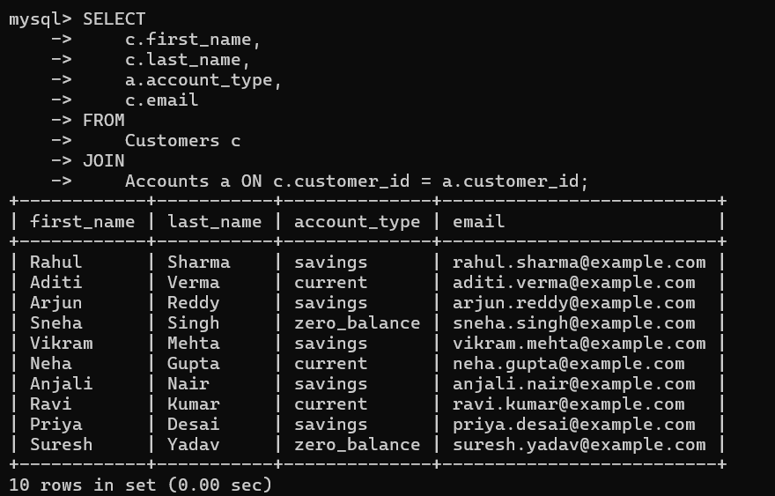

2. Write a SQL query to increase the balance of a specific account by a certain amount.

Update command can be used to update the existing data in a table.

3. Write a SQL query to Combine first and last names of customers as a full_name.

Here concat function is used to concatenate the first name with last name

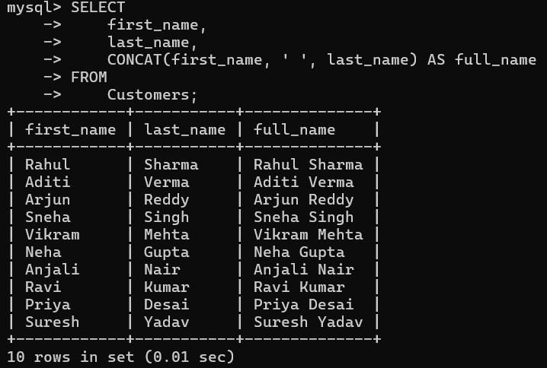

4. Write a SQL query to remove accounts with a balance of zero where the account type is savings.

Delete command is used to delete the records , if condition is not specified then it will delete the all records.

5. Write a SQL query to Find customers living in a specific city.

Use of wild card searching to search data in the table

6. Write a SQL query to Get the account balance for a specific account.

8. Write a SQL query to List all current accounts with a balance greater than $1,000.

Here we have to use AND operator to specify two conditions while filtering out the data

9. Write a SQL query to Retrieve all transactions for a specific account.

10. Write a SQL query to Calculate the interest accrued on savings accounts based on a given interest rate.

Here we have created a column interest acquired to find the required interest amount but it will no impact on original table.

11. Write a SQL query to Identify accounts where the balance is less than a specified overdraft limit.

12. Write a SQL query to Find customers not living in a specific city

Use of wild card searching to find people not living in Mumbai

